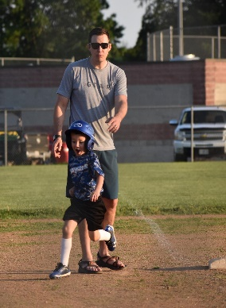
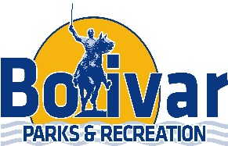
Summer Ball Information Sheet

T-Ball (3-5 Years Old) ***All games will be played @ Bolivar.
Days of Play: Tuesday Nights
League Dates: June 1st-July 5th

Coach Pitch: (6-8 Years Old) ***All games will be played @ Bolivar.
Days of Play: Monday Nights (Doubleheaders)
League Dates: June 1st-July 8th

Youth Baseball/Softball: ***This is the grade that they are going into for the 2022-2023 School Year. All games will be played in Bolivar, Buffalo, Fair Play, Halfway, Morrisville, Pleasant Hope, Skyline & Walnut Grove. (You will play 50% of your games in Bolivar & 50% of your games in our neighboring towns)
League Dates: May 23rd-July 2nd
Crickets (3rd-5th) Friday Nights (Doubleheaders)
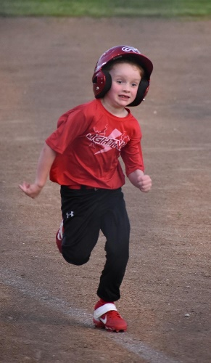
Grasshoppers (3rd-5^{th)} Thursday Nights (Doubleheaders)
Little Ladies (6th-8th) Monday Nights (Doubleheaders)
Little League (6th-8th) Tuesday Nights (Doubleheaders)

