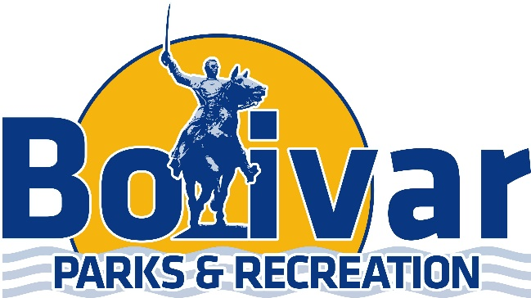

Adult Coed Slow Pitch Schedule

- Sticks & Chicks
- The Screwballs
- Mad Batters
- Suicide Squad
- The Rebels
- Scared Hitless
- Routh Dominators
- Misfits
- Swingers
- Show-Me-Beef

September 22nd
6:30 | Field 5 | 3 | VS | 8
6:30 | Field 6 | 5 | VS | 6
6:30 | Field 7 | 1 | VS | 10
7:30 | Field 5 | 3 | VS | 6
7:30 | Field 6 | 4 | VS | 7
7:30 | Field 7 | 1 | VS | 9
8:30 | Field 5 | 8 | VS | 10
8:30 | Field 6 | 4 | VS | 5
8:30 | Field 7 | 2 | VS | 7
9:30 | Field 7 | 2 | VS | 9
September 29th
6:30 | Field 5 | 7 | VS | 9
6:30 | Field 6 | 2 | VS | 5
6:30 | Field 7 | 4 | VS | 10
7:30 | Field 5 | 1 | VS | 8
7:30 | Field 6 | 2 | VS | 3
7:30 | Field 7 | 6 | VS | 10
8:30 | Field 5 | 5 | VS | 9
8:30 | Field 6 | 1 | VS | 7
8:30 | Field 7 | 3 | VS | 4
9:30 | Field 5 | 6 | VS | 8

October 6th
6:30 | Field 5 | 1 | VS | 6
6:30 | Field 6 | 4 | VS | 8
6:30 | Field 7 | 3 | VS | 7
7:30 | Field 5 | 4 | VS | 6
7:30 | Field 6 | 2 | VS | 10
7:30 | Field 7 | 3 | VS | 9
8:30 | Field 5 | 1 | VS | 5
8:30 | Field 6 | 2 | VS | 8
8:30 | Field 7 | 9 | VS | 10
9:30 | Field 5 | 5 | VS | 7

October 13th
6:30 | Field 5 | 7 | VS | 10
6:30 | Field 6 | 2 | VS | 4
6:30 | Field 7 | 8 | VS | 9
7:30 | Field 5 | 5 | VS | 10
7:30 | Field 6 | 7 | VS | 8
7:30 | Field 7 | 6 | VS | 9
8:30 | Field 5 | 2 | VS | 6
8:30 | Field 6 | 1 | VS | 4
8:30 | Field 7 | 3 | VS | 5
9:30 | Field 7 | 1 | VS | 3

October 20th
6:30 | Field 5 | 1 | VS | 2
6:30 | Field 6 | 3 | VS | 8
6:30 | Field 7 | 5 | VS | 6
7:30 | Field 5 | 3 | VS | 10
7:30 | Field 6 | 5 | VS | 8
7:30 | Field 7 | 6 | VS | 7
8:30 | Field 5 | 1 | VS | 10
8:30 | Field 6 | 2 | VS | 9
8:30 | Field 7 | 4 | VS | 7
9:30 | Field 7 | 4 | VS | 9

