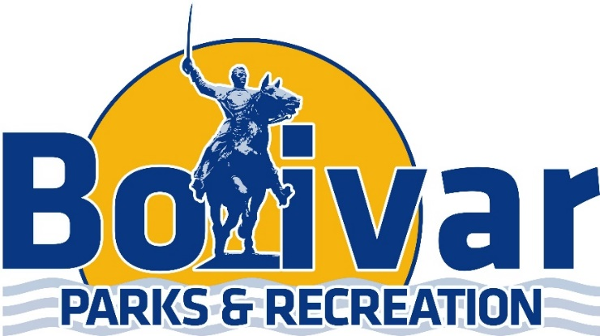

5th/6th Grade Soccer Schedule

September 20th
Time | Field # | Team | VS. | Team
5:30 | 4 | Team Red | VS. | Team Maroon
6:30 | 4 | Team Royal Blue | VS. | Team Gold

September 27th
Time | Field # | Team | VS. | Team
5:30 | 4 | Team Maroon | VS. | Team Gold
6:30 | 4 | Team Royal Blue | VS. | Team Red

October 4th
Time | Field # | Team | VS. | Team
5:30 | 4 | Team Gold | VS. | Team Red
6:30 | 4 | Team Maroon | VS. | Team Royal Blue

October 11th
Time | Field # | Team | VS. | Team
5:30 | 4 | Team Maroon | VS. | Team Red
6:30 | 4 | Team Gold | VS. | Team Royal Blue

October 18th
Time | Field # | Team | VS. | Team
5:30 | 4 | Team Gold | VS. | Team Maroon
6:30 | 4 | Team Royal Blue | VS. | Team Red

***Tournament week will be October 25th-28th -Days will vary on when you play.
***Check out “Bolivar Recreation & Aquatic Center for Updates/Cancellations on Youth Soccer OR sign up on the Remind: Send a text to: 81010 & text this message @bolivarp

