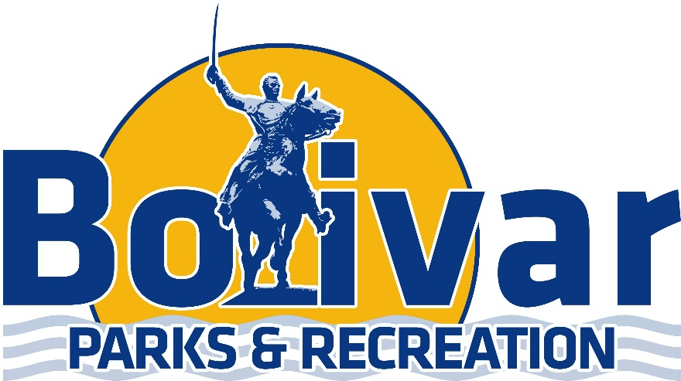

1st/2nd Grade Soccer Schedule

September 21st
Time | Field # | Team | VS | Team
6:00 | 5 | Team Royal Blue | VS | Team Gold
6:00 | 6 | Team Maroon | VS | Team Red
6:45 | 5 | Team Viser | VS | Team Bohner
6:45 | 6 | Team Griswold | VS | Team Ankrom

September 28th
Time | Field # | Team | VS | Team
6:00 | 5 | Team Viser | VS | Team Griswold
6:45 | 6 | Team Bohner | VS | Team Ankrom
6:00 | 5 | Team Royal Blue | VS | Team Maroon
6:45 | 6 | Team Gold | VS | Team Red

October 5th
Time | Field # | Team | VS | Team
6:00 | 5 | Team Royal Blue | VS | Team Red
6:00 | 6 | Team Maroon | VS | Team Gold
6:45 | 5 | Team Viser | VS | Team Ankrom
6:45 | 6 | Team Griswold | VS | Team Bohner

October 12th
Time | Field # | Team | VS | Team
6:00 | 5 | Team Gold | VS | Team Bohner
6:00 | 6 | Team Maroon | VS | Team Viser
6:45 | 5 | Team Griswold | VS | Team Royal Blue
6:45 | 6 | Team Ankrom | VS | Team Red

October 19th
Time | Field # | Team | VS | Team
6:00 | 5 | Team Griswold | VS | Team Gold
6:00 | 6 | Team Royal Blue | VS | Team Ankrom
6:45 | 5 | Team Bohner | VS | Team Red
6:45 | 6 | Team Maroon | VS | Team Viser

***Tournament week will be October 25th-28th -Days will vary on when you play.
***Check out “Bolivar Recreation & Aquatic Center for Updates/Cancellations on Youth Soccer OR sign up on the Remind: Send a text to: 81010 & text this message @bolivarp

