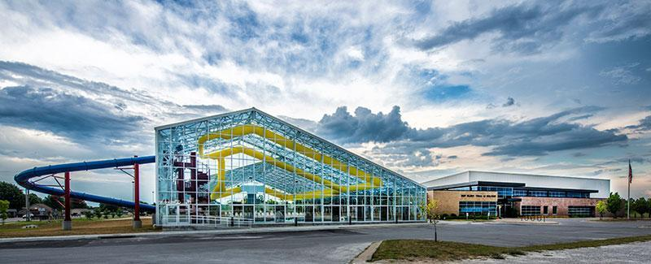

Bolivar Parks & Recreation

Newsletter

September 2021

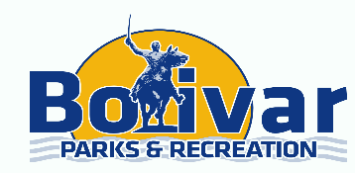

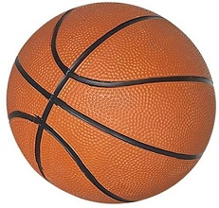

Basketball Registration begins 09/07/21 Season begins 11/01/21

**Bolivar Recreation & Aquatic Center**



Hello Community,

Wow, this summer was busy! We’re super excited to have been apart of your summer. Whether it was pool time, fitness or childcare, we’re happy to have served you and your family.

We have some fun events coming up this fall! We’ll see you at Country Days, there will be some special people in the dunk tank that you just might want to dunk!

Labor Day will be the last day for open swim for the 2021 season. Morning swim will continue through Fall.

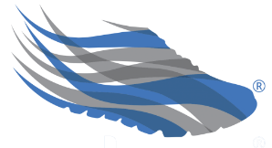

SilverSneakers Fitness Programs

NO morning swim NO water aerobics or fitness classes on Labor Day

Aquatic Center hours of operation on Labor Day

1:00pm-5:00pm

Recreation Center hours of operation on Labor Day

11:00am-5:00pm

Need before or after school care for your child? Ask Mary for details

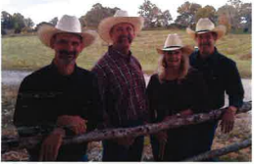

Ozark Country Band No Dance on 9/4/2021 dances will resume on 09/18/2021, 10/02/2021, 11/06/2021, 12/04/2021, New Year Party 12/31/2021.

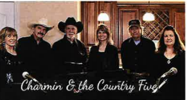

Charmin & the Country Five

09/18/2021, 10/16/2021, Halloween Costume Party & Contest 10/30/2021, 11/20/2021, 12/18/2021.