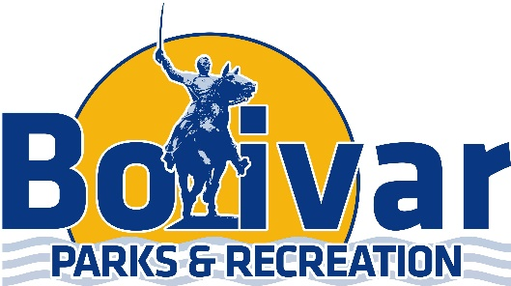

Bolivar Parks & Recreation
1710 W Broadway Bolivar, MO 65613
Shania Francka-Parks & Rec Sports Coordinator
417-399-0690 sfrancka@bolivar.mo.us

Pee-Wee Individual Registration

Child’s First Name:_________________________ Child’s Last Name:___________________________________

Age:_________ Birth Date:_______-________-_________ Parent Guardians Name:________________________

Home Address:________________________________________ City:______________________________

Zip Code:______________________ Home Phone:________________________ Cell Phone:______________________

Emergency Number:___________________________ Email Address:________________________________________

Shirt Size: YS YM YL AS AM AL AXL (Circle One)

Please mark YES or NO if interested in helping coach: Yes_____ No______

Office Use Only:

Receipt # & Amount:_________________________ Team:______________________________________

Coach:_________________________________________

Pee-Wee Soccer is a co-ed instructional league designed to introduce 3 & 4 year old’s to the game of soccer. This league offers practices followed by 4 weeks of games. Games will consist of practice during the 1st half and a scrimmage the 2nd half. All participants will receive a t-shirt.

Ages: Must be 3 or 4 years old by September 1st.
Fall Registration Deadline: August 16th
Fee: $30 (First Child) $25 (Second Child) $25 (Bolivar Park & Rec Fitness Members)
Practice Time: Will be determined by the Coaching staff.
Game Time: Games will be played on: September 30th, October 7th, October 14th. October 21st

